**Oil Pattern Distance**

**43**

**Reverse Brush Drop**

**40**

**Oil Per Board**

**50**

**ul**

**5**

**- 2022 Junior Gold Advancers Round**

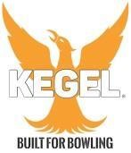

**Forward Oil Total**

**24.95**

**mL**

**Reverse Oil Total**

**7**

**mL**

**Volume Oil Total**

**31.95**

**mL**

KEGEL FIRE OIL

